OCNMS Manuscript

Tolimieri, N.

Liu, O.

Sullaway, Gsul.

Samhouri, J.

The Harvey, C.

Feisty, B.

Shelton, Olaf

The Andrews, K.

Frickster, K.

Williams, G$.

Lonhart, S. 130cf

Others…from OCNMS etc., Gary, Joe, (Sicilian connection) etc. or … Jenny?

Order of authors…just listing out here.

# Abstract

# Introduction

Kelp forests are important…lots of research…assemblage structure related to habitat….monitoring for the OCNMS

Recent events….

1. blob and rockfish recruitment…
2. otters moved south and urchin recovery…
3. sea star die-off. Recovery and effects on the community.

Specifically we ask, do fish and invertebrate assemblages differ among sites, and are differences in fish and invertebrate assemblages related to habitat? We then examine three vignettes related to recent occurrences on the West Coast: 1) rockfish recruitment events, 2) increase in urchin abundances, 3) relationships between starfish and their prey.

# Materials and Methods

## Study sites

We conducted dive surveys at five sites in late July or early August of 2016-2019 within the Olympic Coast National Marine Sanctuary (OCNMS, designated in 1994) along the coast of Washington, U.S.A. (Fig. 1). These sites span much of the OCNMS from Destruction Island in the south to Neah Bay in the north. Four sites were on the outer coast, while Neah Bay is within the Strait of Juan de Fuca. All sites were relatively protected from wave action and had subtidal rocky reefs and supported kelp stands consisting of *Macrocystis pyrifera* and/or *Nerocystis luekana* as well as understory algae such as *Pterygophora californica* (Shelton et al. 2018). More here?

## Survey design

At each site, we conducted visual surveys on scuba on 30 x 2 m transects to quantify: 1) fish abundance, 2) macroinvertebrate abundance, 3) kelp abundance, 4) other biotic habitat, and 5) substratum type (abiotic habitat, e.g., cobble, pavement, etc). The overall approach was modified from Pondella et al. (2019). At each site, we sample two locations marked by separate down lines and two depths (5 m and 10 m). One pair of divers sample fish and quantified biotic habitat. The second pair of divers sampled macroinvertebrates and kelp and quantified substratum type. The lead diver laid down the transect tape and counted fish or macroinvertebrates and kelp. The second diver followed along the transect recording biotic habitat or substratum characteristics respectively. Both biotic habitat and substratum type were quantified using uniform point contact (UPC) methods by recording the organism or substratum directly under every meter mark along the transect for 30 data points per transect. Each pair of divers began transects from the same drop point marked by the down-line and followed the same overall heading. However, pairs did not necessarily cover the exact same ground, so one cannot directly match fish counts to substratum characteristics at the transect level, for example. Therefore, we often summarize data by year x site x depth for some comparisons.

We counted and estimated the size (total length) of all fishes we observed that within 2 m of the bottom and greater than 5 cm total length. For rockfishes *Sebastes* spp, however, we counted estimated sizes for all individuals since we were interested in monitoring rockfish recruitment. Divers estimated visibility on each transect by determining the distance at which the lead diver could see the fingers their buddy. Transects with visibility less than 2.0 m were excluded from the analyses including fishes.

For biotic habitat, the diver recorded the organism directly under the transect every meter mark (universal point contact, UPC). Biotic habitat included the following functional groups: brown algae, red algae, green algae, encrusting species, diatom layer, eelgrass/surfgrass, non-mobile invertebrates, or non-living substratum (rock/sand).

Large mobile invertebrates were enumerated for individuals greater than 2.5 cm in diameter or width, with the exception of sea stars where we measured radius. We counted individuals under prostrate algae and within bottom topography and on algae up to a height of 1 m above the substrate. This category included species of sea urchins, sea star, sea cucumbers, crabs, bivalves, nudibranchs, etc. We included only species that were easily identifiable to avoid concerns about the detection of cryptic species. For abundant species the transect was broken into 10-m segments, and the distance at which 30 individuals were counted per segment was noted, to be used in expansion calculations. We also recorded sea urchin test diameter, sea star radius, and crab carapace width.

We counted canopy-forming kelp species within on the same transect as mancroinvertebrates. For *Macrocystis pyrifera* the stipes were counted when greater than 1 m in height. *Nereocystis luetkeana* and *Pterygophora californica* plants with stipes greater than 30 cm in height were included, along with other brown algae species greater than 30 cm in overall length. We again used the segment subsampling for abundant species described for invertebrate species.

We classified abiotic habitat (substratum) based on a simplified version of a system used extensively on the U.S. West Coast (Pearcy et al. 1989, Hixon et al. 1991, Stein et al. 1992, Green et al. 1999, Tolimieri et al. 2008): sand, cobble, boulder, or bedrock; these features were recorded every meter (UPC). Additionally, we included an estimate of the slope every 10 m by estimating the drop in elevation across the 2-m width of a transect as: 0-10 cm, 10-100 cm, 1-2 m, or >2 m.

Expansion methods for kelp and urchins

Something about univariate comparisons?

## Multivariate ordinations

We used distance-based redundancy analysis (dRDA, implemented via the ‘capscale’ function in R 4.0.2; Legendre and Anderson 1999, R Core Team 2020) to ordinate multivariate patterns and understand relationships between fish or invertebrate community structure and habitat predictor variables (kelp, UPC, and substratum). First, we ordinated transects (fish or invertebrates) among sites to determine whether assemblage structure varied among sites (where site x depth x years were the constraining variables). We then also conducted a second set of ordinations using habitat variables to constrain the ordination. For this second set, we used site x year x depth averages because habitat variables did not map directly to fish or invert transects. In all cases, we square-root transformed the data prior to analysis to reduce the effect of highly abundant (Clarke and Warwick 2001) species and used Bray-Curtis distance. Note, rockfish young-of-year (YOY) were excluded from the analyses due to their ephemeral and highly variable nature.

The habitat variables matrix included kelp density, biotic habitat, and substratum characteristics. For kelp density, we included the stipe counts for four taxa *M. pyrifera, N. luekana* , *P. californica,* and ‘other’ macroalgae. For the biotic habitat and the substratum data, we first conducted separate principal components analyses (PCA) to reduce the number of variables entering into dRDA above and to understand variation among sites and depths. We used the first two PCA axes from each analysis in the above dRDAs after averaging each by site x year x depth.

## Rockfish recruits

How we id them

## Urchins and Kelp

Expansion info

## Sea stars and prey

We calculated separate sea star and prey indices by first examining sea star diets. For sea stars, we lumped all species but excluded *Henricia* spp because they eat primarily sponges and bacteria. Based on the sea star diets we lumped bivalves,shelled mollusks, shelled gastropods, and the three urchins to produce a prey index. We then plotted prey abundance against total sea start abundance.

# Results

Probably some intro info on # spp etc. Maybe general habitat description. Some figs in sup some here…perhaps habitat description figures.

## Abiotic habitat

Sites varied in their abiotic substratum characteristics, and these differences were largely consistent across depth. The substratum at Destruction Island and Tatoosh Island comprised primarily bedrock (Fig. 3); these sites also had high relief relative to other sites with greater than 25% of the bottom having changes in elevation of >2-m across the width of the transects (Fig. 4). The bottom at Neah Bay was also primarily bedrock but the relief was much lower being primarily in the 10-cm to 1-m bin. At Cape Johnson and Cape Alava boulder made up the most common substratum type and relief was generally low in the 10-cm to 1-m bin.

## Macro-algae/Kelp

After initial data analysis, we further analyzed three species and one combined group: *M. pyrifera, N. leukana, P. californica,* and ‘other’ (Fig. 2). *M. pyrifera* was found on the 5-m transects at Cape Johnson and Neah Bay but was absent or less abundant in other areas. *N. leukana* was also more abundant at 5-m depths but was also found on 10-m transects at Tatoosh Island and Neah Bay. *N. leukana*  was less common at Cape Johnson and Neah Bay that at other sites. *P. californica,* and under-story kelp, occurred at a sites at 5-m in similar abundance, although densities were slightly higher at Tatoosh Island and Neah Bay than other areas. *P. californica* was also found at 10-m at Tatoosh and Neah Bay.

## Multivariate results

Fish assemblages differed among sites, depths, and years (dRDA, p < 0.001, Fig. 5). While there was variation among years for all sites, Cape Johnson ordinated separately from Cape Alava. Neah Bay and Tatoosh Island were intermediate between the previous two while Destruction Island assemblages were highly variable through time. Some species like black rockfish (SEME) were found at all sites (Fig. S 1) and did not distinguish among site in the ordination. Other like tubesnout (AUFL) were abundant at a subset of sites in 2016 and to a lesser extent in 2019. Greenlings (HEXA), copper rockfish (SECA), China rockfish (SENE), lingcod (OPEL), and cabezon (SCMA) characterized Cape Alava and Neah Bay, with the exception of 2016. Surfperch (EMBI) were also common at Cape Alava and at Cape Johnson, but only in 2017 and 2018 for the latter.

The invertebrate ordination showed a clear separation of sites, especially when factors were averaged by site and year (dRDA, p < 0.001, Fig. 6). While there was some variation among years, it was much less than the spread among sites. Tatoosh Island was notable for having more urchins (Axis 1) than other sites (Fig. S 2-5). Urchins also characterized Destruction Island and Neah Bay relative to other sites but were much less common at these two sites than at Tatoosh Island. Tunicates, leather stars, large barnacles and orange cucumbers were more common at Tatoosh Island, Destruction Island, and Cape Alava that at Neah Bay, and at Cape Johnson in 2017 and 2018 than in 2016 and 2019.

For the PCA of biotic benthic habitat, the first PC separated transects with red versus brown algae (Fig. S 1). The second PC distinguished among transects with encrusting species and non-mobile invertebrates from those with more red or brown algae. Thus PC2 gives an indication of understory algal coverage. There was no clear separation of sites within this ordination, however.

The PCA of abiotic substratum characteristics (Fig. S 7) separated transects of primarily bedrock from those with boulder structure along the first PC. Destruction Island and Tatoosh Island had more bedrock than other sites, while Cape Johnson and Cape Alava had more boulder or cobble habitat. The second PC explained differences among transects in slope (0-10 cm vs 10 cm – 1 m drop over the 2-m width of the transect). This second PC did not appear strongly associated with sites ro depths.

The fish assemblage did not show strong correlation with the combined kelp-biotic-substrate habitat matrix (dRDA , p > 0.05, Fig. S 8). This is not entirely surprising given Cape Alava and Cape Johnson, which had dissimilar fish assemblages (Fig. 5), had similar biotic benthic habitats (Fig. S 7). Moreover, given that all transects were done in somewhat sheltered kelp forests, the habitat may not have varied significantly among sites from the point of view of a fish. Large scale factors (circulation, settlement, etc) may have been more important in driving differences in fish assemblages among sites.

Associations between macroinvertebrates and habitat features were largely driven by urchins and Tatoosh Island (Fig. 7). All three urchin species loaded positively on the first and second axes indicating positive associations with brown understory algae, *N. leukana*, *P. californica,* and other macroalgae and areas with boulder habitat (axis one, Fig. 7).

## Rockfish recruitment

Recruitment of rockfishes was temporally episodic (Fig. 8). While the intensity of recruitment varied among sites within a year, most species showedstrong recruitment at multiple sites within a specific year. However, species had successful recruitment in different years. Black and yellow tail rockfishes showed strong recruitment at most sites in 2016 and to a lesser extent in 2019. In contrast, copper rockfish (including unidentified recruits, which were most likely copper or quillback) had high recruitment at most sites in 2019. Canary recruitment pulses occurred in 2016 and 2018.

## Urchins and kelp

Green, red, and purple urchins all showed increase in abundance from 2016 to 2017 at Tatoosh Island (Fig. S 2). Following this initial increase, both green and red urchins declined through 2019, while purple urchins remained abundant. Qualitative observations and urchin test size distributions (measured in 2018 and 2019, Fig. S 9) suggest a recruitment pulse occurred sometime in 2017 or early 2018. Purple urchins showed low densities but minor increases at Destruction Island from 2017-2019 (Fig. S 2).

Relationships between urchins and kelp differed among and within sites. Among sites urchins were negatively associated with *M. pyrifera* but positively associated with *N. luekana* as is evident from the first canonical axis in the invertebrate-habitat ordination (Fig. 7). Sites with high abundance of *M. pyrifera* had few urchins (Fig. 9). However, this effect was largely due to the absence of *M. pyrifera* at Tatoosh Island, so the effect may geographical and not biological.

The positive association between urchins and *N. leukana* among sites (Fig. 7) stemmed from both being found at Tattoosh Island (Fig. 9). However, within Tatoosh, the abundance of *N. luekana* was negatively correlated with the abundance of purple urchins (r = XX , Fig. 9). Thus, as the densities of purple urchins increased at Tatoosh Island, kelp density decreased (Fig. 2). Interestingly, variability in the density of *P. californica* seemed to decrease with urchin density for both purple and red urchins (Fig. 9). The same was true for *N. leukana* and red urchins. For red urchins, the relationships may be partially spurious; red urchins increased then declined all while *N. pyrifera* declined likely due to grazing by purple urchins.

Section probably needs some stats support?

Intro should reference Shelton 2018. Otters were there, then moved south, urchins returned.

## Sea stars

Intro should connect to sea star die-off obviously. 1. Sea star are ‘back’ a little. 2. Potential effects on invert assemblage.

Recruitment of sea star yoy in 2017. Latitude effect with higher recruitment to the south. Spp not identified.

Among sites, prey abundance was negatively correlated with the density of sea stars at the transect level (some non-linear stats, Fig. 10). However, much of this relationship was due to differences among sites, especially Tatoosh and Destruction Islands. Prey items were most abundant but also highly variable (large variation along the y-axis in Fig. 10) at Tatoosh Island, where sea stars were less abundant. The high variability in prey at Tatoosh Island was most likely due to the increase in purple, red, and green urchins followed by a decrease in red and green urchins. However, this variability within Tatoosh does not appear to be strongly associated with sea star predation. Sea stars were most abundant and also highly variable at Destruction Island and to a lesser extent Cape Alava, where prey was less abundant. Both sea stars and invertebrate prey were comparatively uncommon at Cape Johnson and Neah Bay.

Within Destruction Island, there was a negative relationship between sea stars and prey abundance suggesting that sea stars exert top-down pressure on the subtidal assemblages when at higher abundance. While Destruction Island received a pulse of sea star recruitment in 2017, several stars increased and then declined in abundance from 2016 to 2019 causing the variability in the abundance of sea stars seen on the x-axis in Fig. 10.

# Discussion

# Acknowledgments

We thank XX anonymous reviewers and XX, XX, and XX for comments on the manuscript.

# Literature Cited

Clarke, K. R., and R. M. Warwick. 2001. Change in Marine Communities: An Approach to Statistical Analysis and Interpretation; 2nd edition. PRIMER-E, Plymouth, UK.

Green, H. G., Y. M.M., R. M. Starr, V. M. O'Connell, W. W. Wakefield, D. E. Sullivan, J. E. McRea, and G. M. Cailliet. 1999. A classification scheme for deep seafloor habitats. Oceanologica Acta **22**:663-678.

Hixon, M. A., B. N. Tissot, and W. G. Pearcy. 1991. Fish assemblages of rocky banks of the Pacific Northwest, Final Report, OCS Study 91-0052. U. S. Minerals Management Service, Camarillo, California.

Legendre, P., and M. J. Anderson. 1999. Distance-based redundancy analysis: testing multispecies responses in multifactorial ecological experiments. Ecological Monographs **69**:1-24.

Pearcy, W. G., D. L. Stein, M. A. Hixon, E. K. Pikitch, W. H. Barss, and R. M. Starr. 1989. Submersible observations of deep-reef fishes of Heceta Bank Oregon USA. Fishery Bulletin **87**:955-966.

Pondella, D. J., S. E. Piacenza, J. T. Claisse, C. M. Williams, J. P. Williams, A. J. Zellmer, and J. E. Caselle. 2019. Assessing drivers of rocky reef fish biomass density from the Southern California Bight. Marine Ecology Progress Series **628**:125-140.

R Core Team. 2020. R: A language and environment for statistical computing. R Foundation for Statistical Computing, Vienna, Austria. URL <https://www.R-project.org/>.

Shelton, A. O., C. J. Harvey, J. F. Samhouri, K. S. Andrews, B. E. Feist, K. E. Frick, N. Tolimieri, G. D. Williams, L. D. Antrim, and H. D. Berry. 2018. From the predictable to the unexpected: kelp forest and benthic invertebrate community dynamics following decades of sea otter expansion. Oecologia **188**:1105-1119.

Stein, D. L., B. N. Tissot, M. A. Hixon, and W. Barss. 1992. Fish-habitat associations on a deep reef at the edge of the Oregon continental-shelf. Fishery Bulletin **90**:540-551.

Tolimieri, N., M. E. Clarke, H. Singh, and C. Goldfinger. 2008. Evaulating the SeaBED AUV for monitoring groundfish in untrawlable habitat. Pages 129-141 *in* J. R. Reynolds and H. G. Greene, editors. Marine Habitat Mapping Technology for Alaska. Alaska Sea Grant College Program, University of Alaska Fairbanks.

# Tables

Table . List of fish species observed on visual surveys. Taxa were lumped into Group for statistical analyses. Note, rockfish young-of-year (YOY) were excluded from the ordinations due to their ephemeral nature.

|  |  |  |
| --- | --- | --- |
| **Species** | **Common name** | **Group** |
| *Aulorhynchus flavidus* | tubesnout | AUFL |
| bait-sardines-anchovy | bait | BAIT |
| *Brachyistius frenatus* | kelp surfperch | EMBI |
| Clupeidae | herring | BAIT |
| *Cymatogaster aggregata* | shiner surfperch | EMBI |
| *Embiotoca lateralis* | striped surfperch | EMBI |
| Embiotocidae | surfperches | EMBI |
| *Engraulis mordax* | northern anchovy | BAIT |
| *Hemilepidotus hemilepidotus* | red irish lord | HEXA |
| *Hexagrammos spp* | greenlings | HEXA |
| *Hexagrammos decagrammus* | kelp greenling | HEXA |
| *Hexagrammos lagocephalus* | rock greenling | HEXA |
| *Hexagrammos stelleri* | whitespotted greenling | HEXA |
| *Ophiodon elongatus* | lingcod | OPEL |
| *Oxylebius pictus* | painted greenling | HEXA |
| *Rhacochilus vacca* | pile perch | EMBI |
| *Sardinops sagax* | Pacific sardine | BAIT |
| *Scorpaenichthys marmoratus* | cabezon | SCMA |
| *Sebastes caurinus* | copper rockfish | SECA |
| *Sebastes caurinus YOY* | copper rockfish yoy | SECAy |
| *Sebastes melanops/flavvidus YOY* | yellowtail-black yoy | SEBYTy |
| *Sebastes melanops* | black rockfish | SEME |
| *Sebastes melanops YOY* | black rockfish yoy | SEMEy |
| *Sebastes mystinus* | blue rockfish | SEMY |
| *Sebastes nebulosus* | China rockfish | SENE |
| *Sebastes pinniger YOY* | canary rockfish yoy | SEPIy |
| *Sebastes YOY* | rockfish yoy | RYOY |

# Figures

All figs currently first-draft. Will need to clean up, match colors for consistency etc.

Fig. Map.

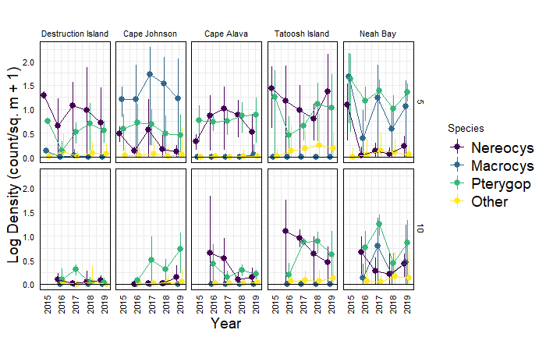

Fig. 2 Macroalgal abundance by site x year x depth.

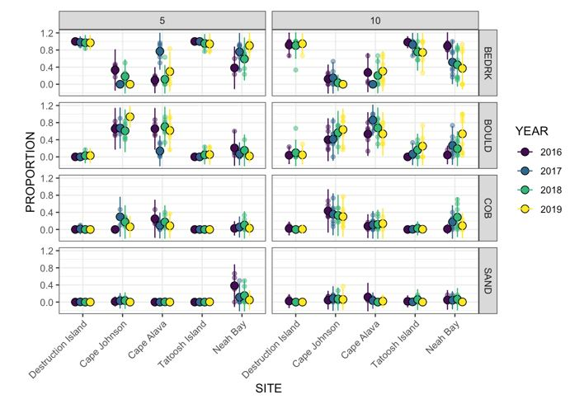

Fig. 3 Substratum characteristics by site year and depth. BEDRK = bedrock, BOULD = boulder, COB = cobble, SAND = sand.

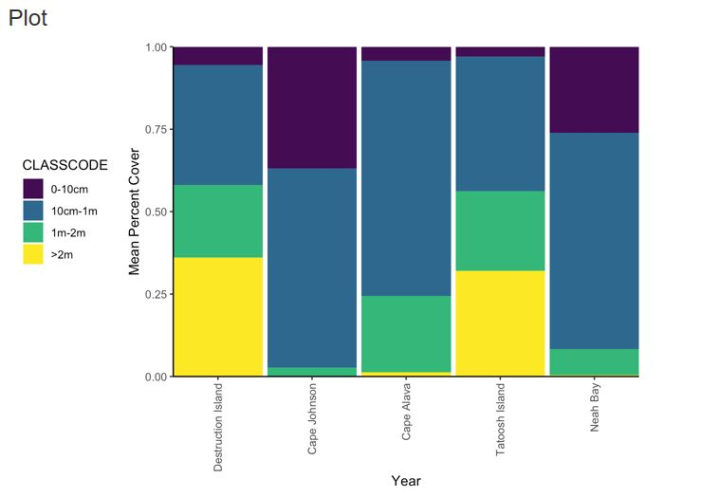

Fig. 4 Estimate of slope sites, summarized across depths and years. Ranges are the drop in elevation across the width of a 2-m transect. Data are the average of XX measurements per 30-m transect.

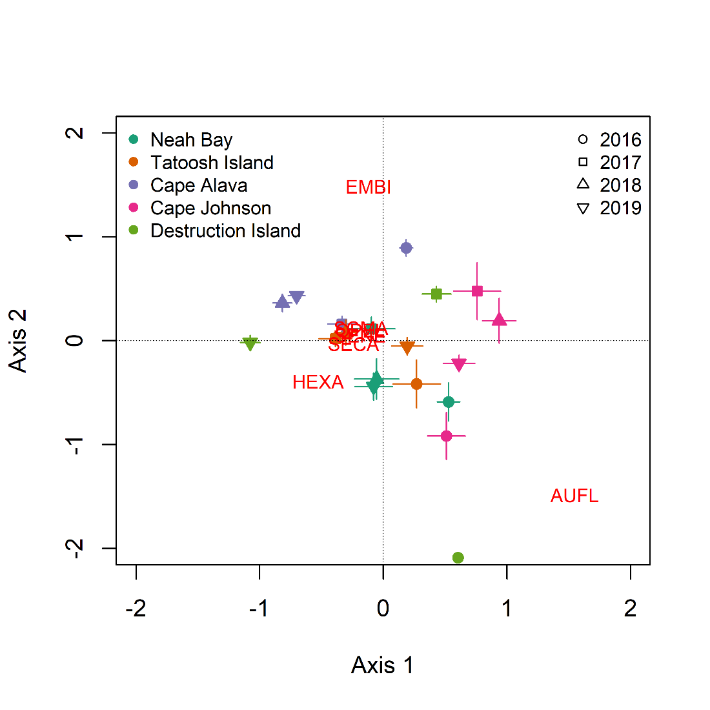

Fig. Ordination of sites based on the fish taxa present on 30 x 2 m transects from a distanced-based redundancy analysis. The analysis used individual transects, but the axes were averaged by site and year for clarity in the presentation. Error bars indicate ± 1.0 s.e. Red text shows the loadings for fish taxa. The overlapping taxa just left of the center are: SCMA, SENE, SECA, OPEL. See Table 1 for taxa designations.

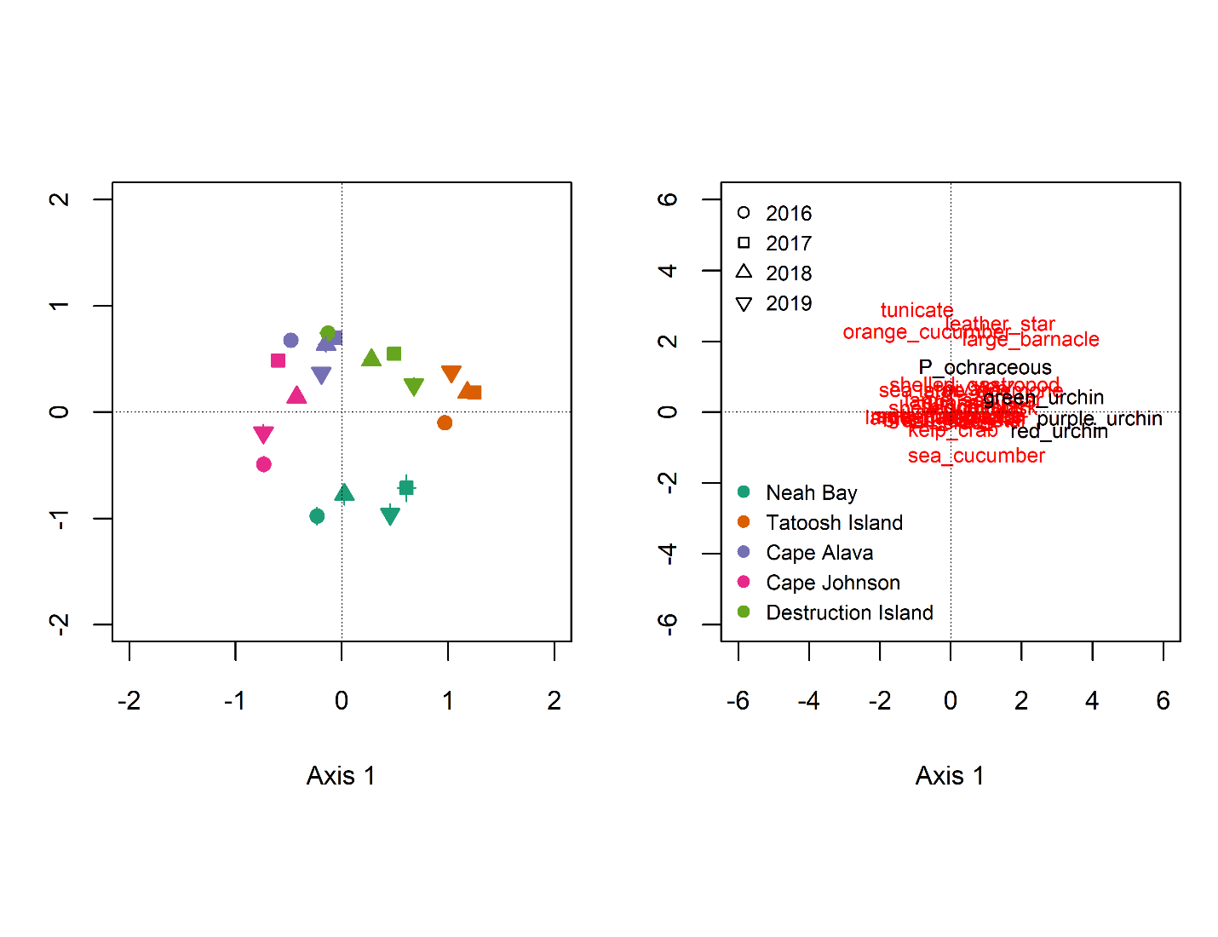

Fig. Ordination of sites based on the invertebrate taxa present on 30 x 2 m transects from a distanced-based redundancy analysis. The analysis used individual transects, but the axes were averaged by site and year for clarity in the presentation. Error bars indicate ± 1.0 s.e. In most cases, error bars are smaller than the points. The results are presented in two panes with the species loadings plotted on the second pane for readability. Species colors on the loadings pane are for readability and used to emphasize particular species; they do not have any statistical meaning.

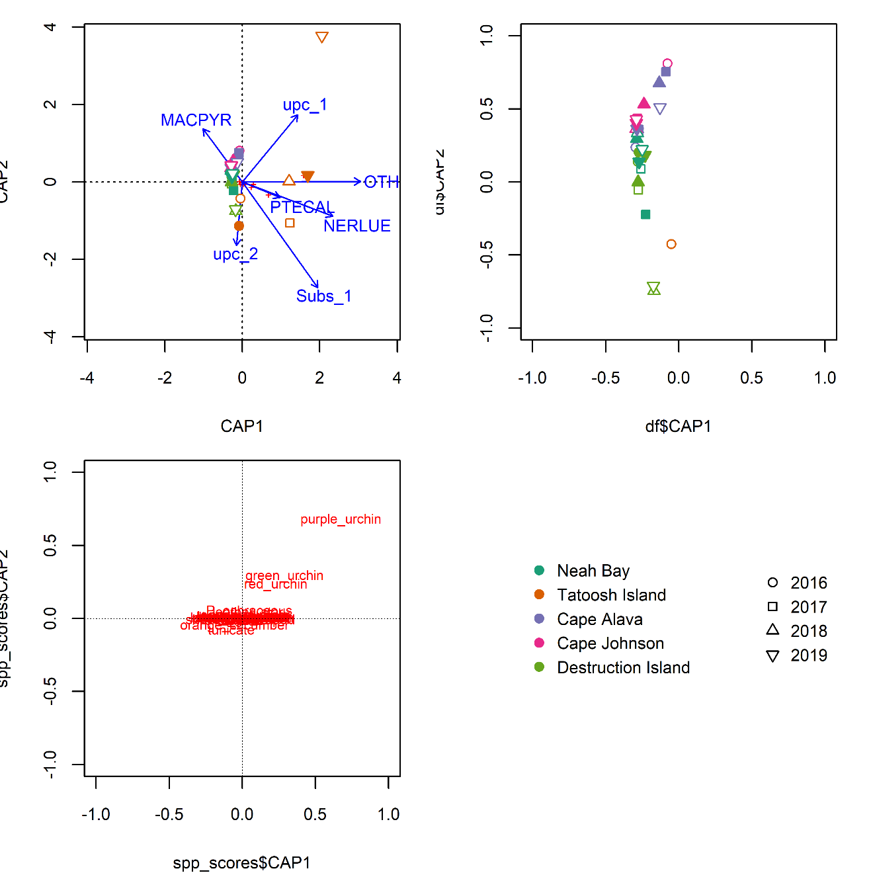

Fig. Inverts vs habitat CAP MACPYR = *Macrocystis pyrifera*, NERLUE = *Nerocystis luekana*, PTECAL = *Pterygophora californica. Update after updating names in figure.*

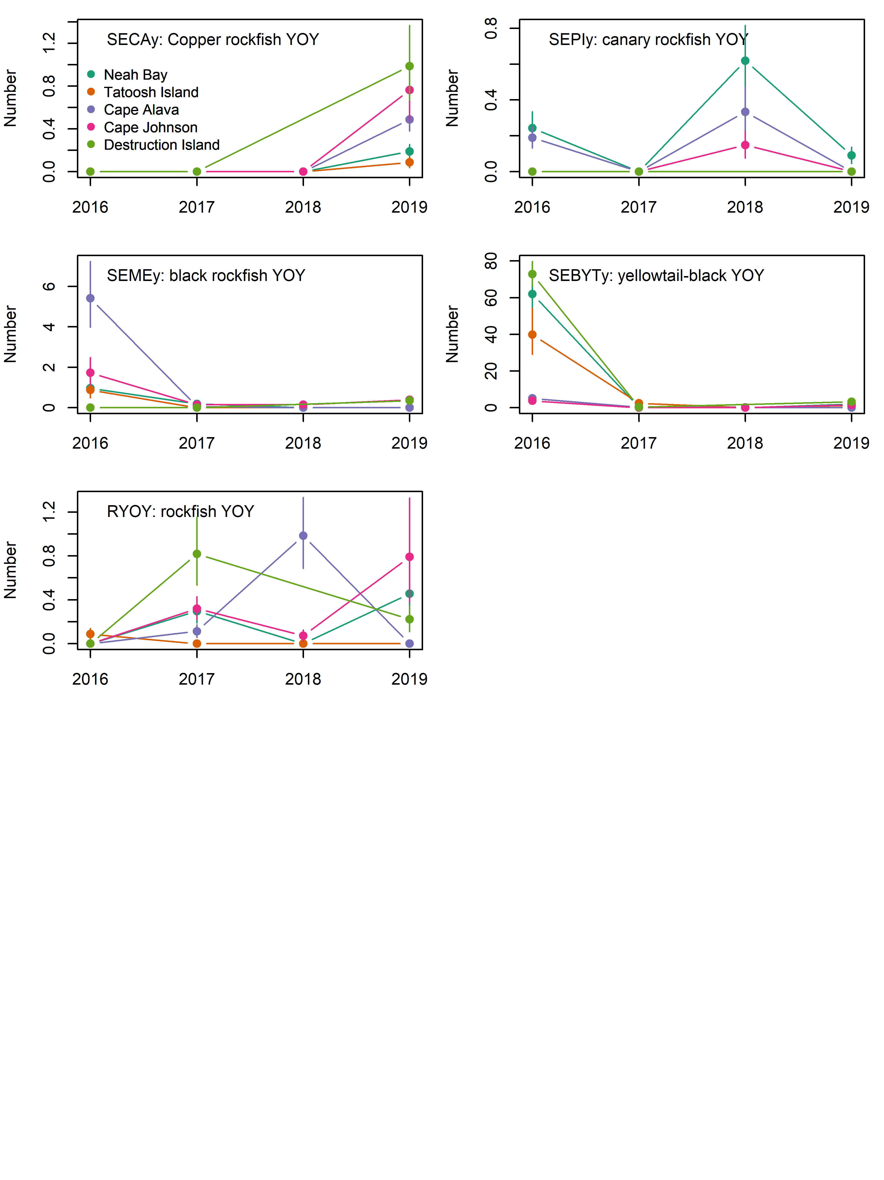

Fig. Abundance of rockfish recruits (young-of-year, YOY) by site and year. Data are the back-calculated site x year means (log x+1) and s.e.

Would be good to add years to each of these…

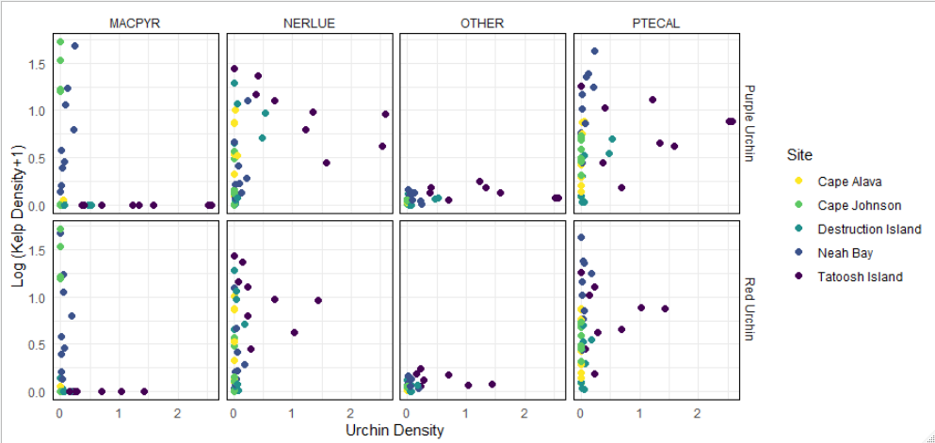

Fig. Relationships between the density of canopy and understory kelps and the abundance of purple and red urchins. MACPYR = *Macrocystis pyrifera*, NERLUE = *Nerocystis luekana*, PTECAL = *Pterygophora californica.*

Label by year for Tatoosh…. Reorder to have Macro, Nereo, Ptero, Other

Probably should add kelp through time figures

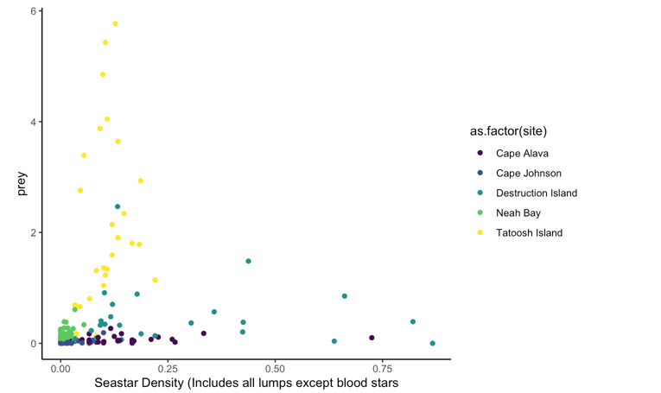

Fig. Sea stars vs Prey. Not linked. *Henricia* spp. Excluded because they eat sponges and bacteria.

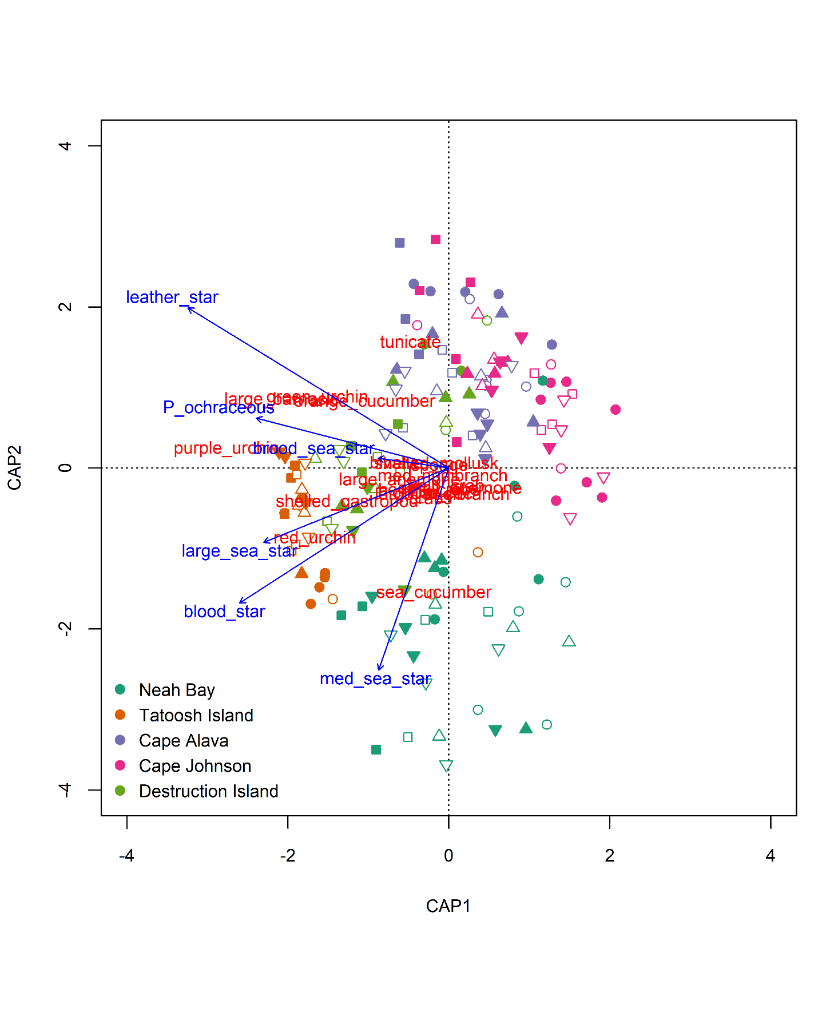

Fig. Ordination (dRDA) of sea stars versus their potential prey items.

Average to make comparable to other ordinations.

# Supplement

## Figures

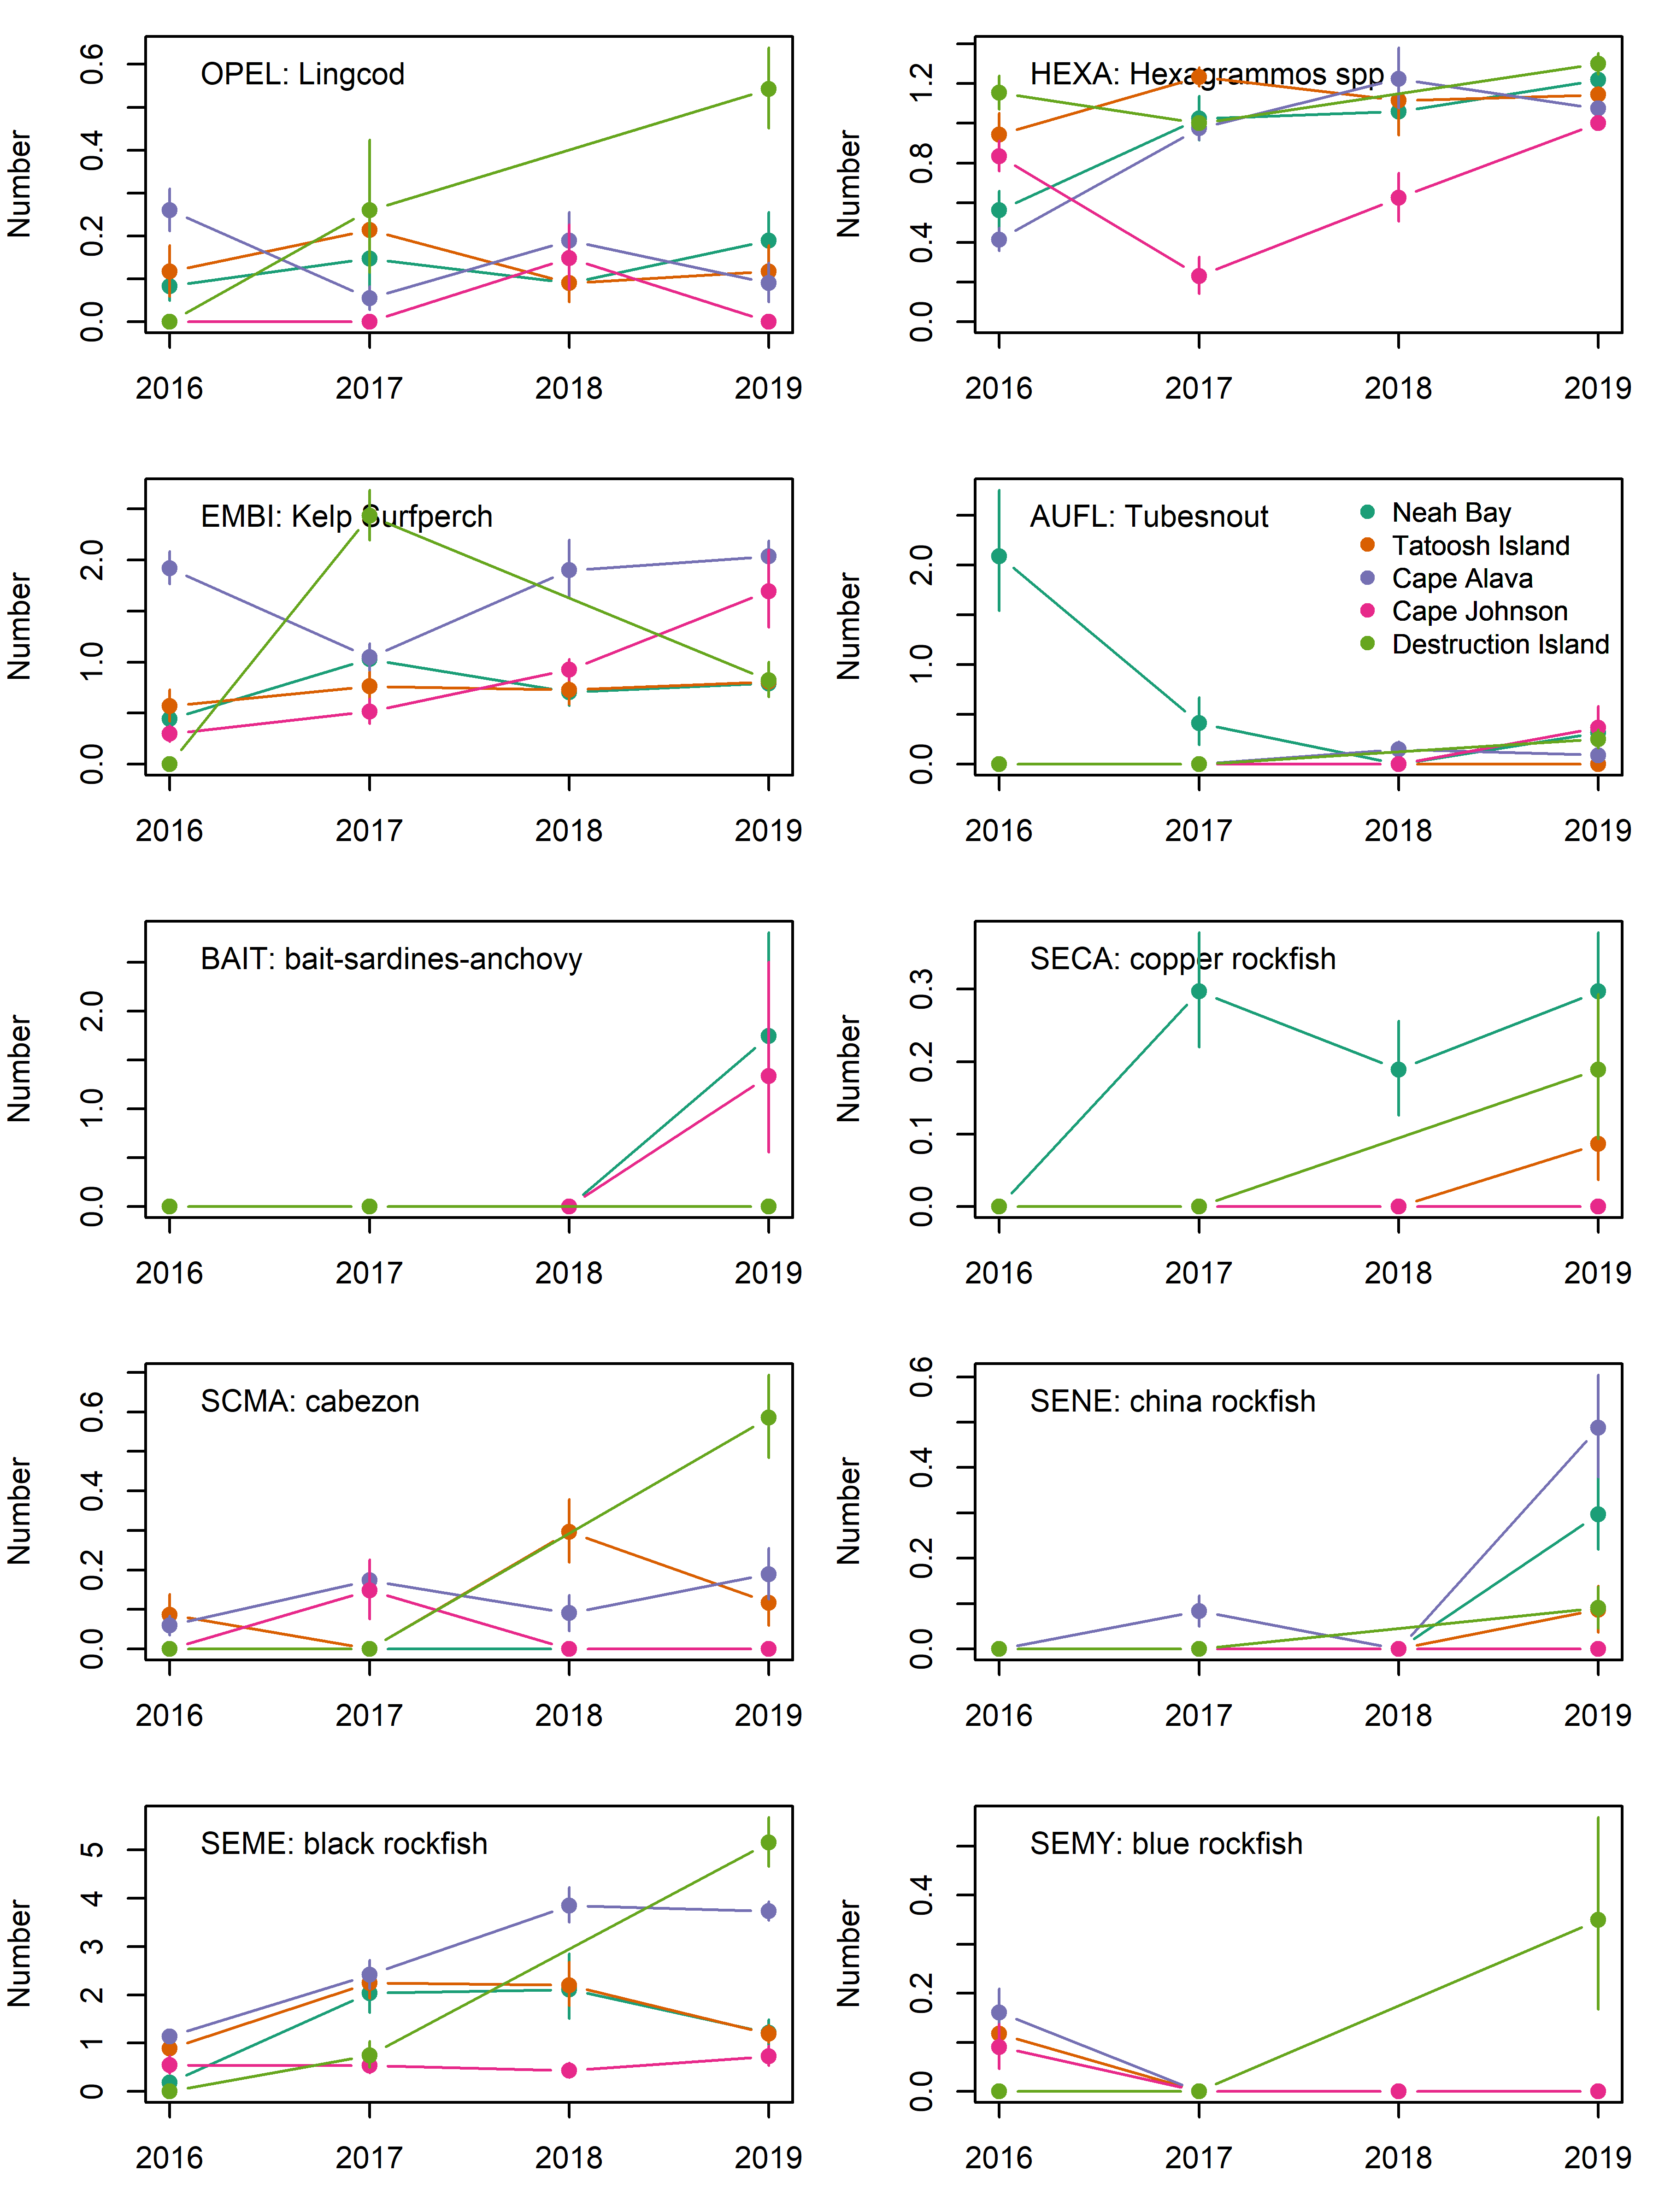

Fig. S Abundance of the primary fish species seen on at five sites from 2016-2019. Data are the back-calculated site x year means (log x+1) and s.e.

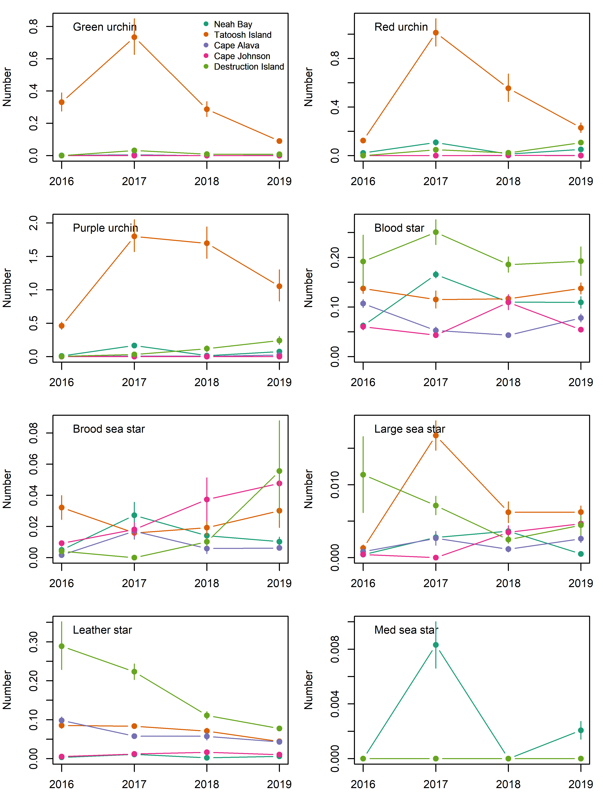

Fig. S Abundance of the primary invertebrate species seen on at five sites from 2016-2019. Data are the back-calculated site x year means (log x+1) and s.e.

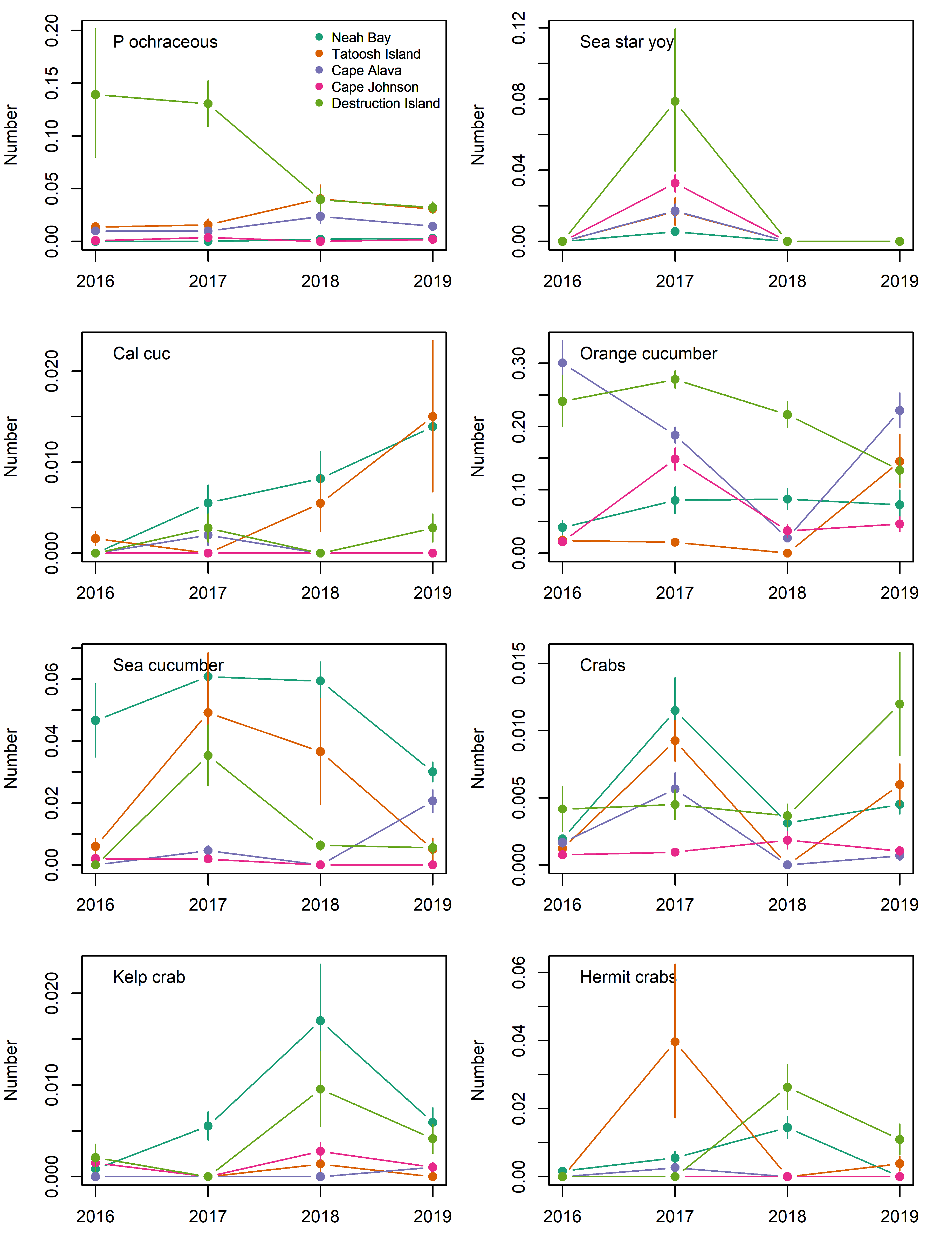

Fig. S Abundance of the primary invertebrate species seen on at five sites from 2016-2019. Data are the back-calculated site x year means (log x+1) and s.e.

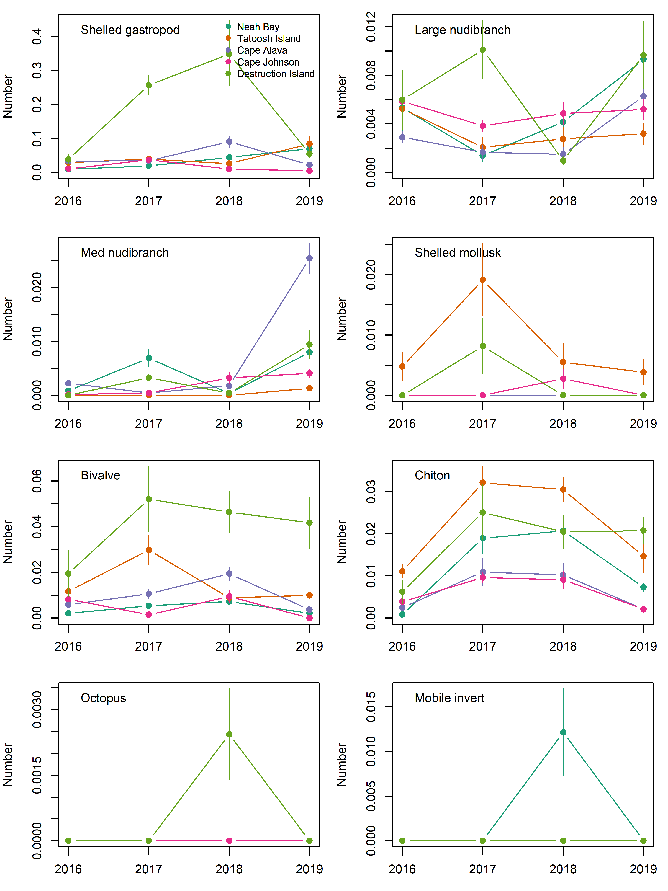

Fig. S Abundance of the primary invertebrate species seen on at five sites from 2016-2019. Data are the back-calculated site x year means (log x+1) and s.e.

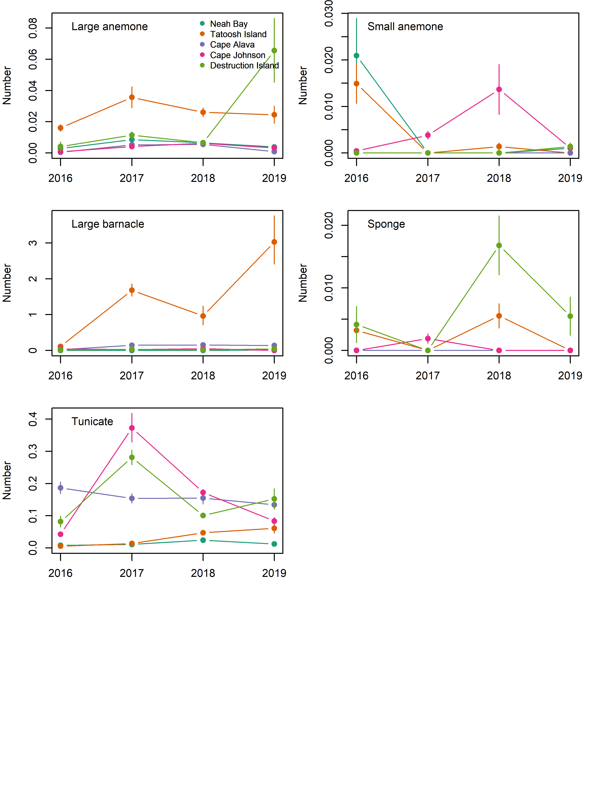

Fig. S Abundance of the primary invertebrate species seen on at five sites from 2016-2019. Data are the back-calculated site x year means (log x+1) and s.e.

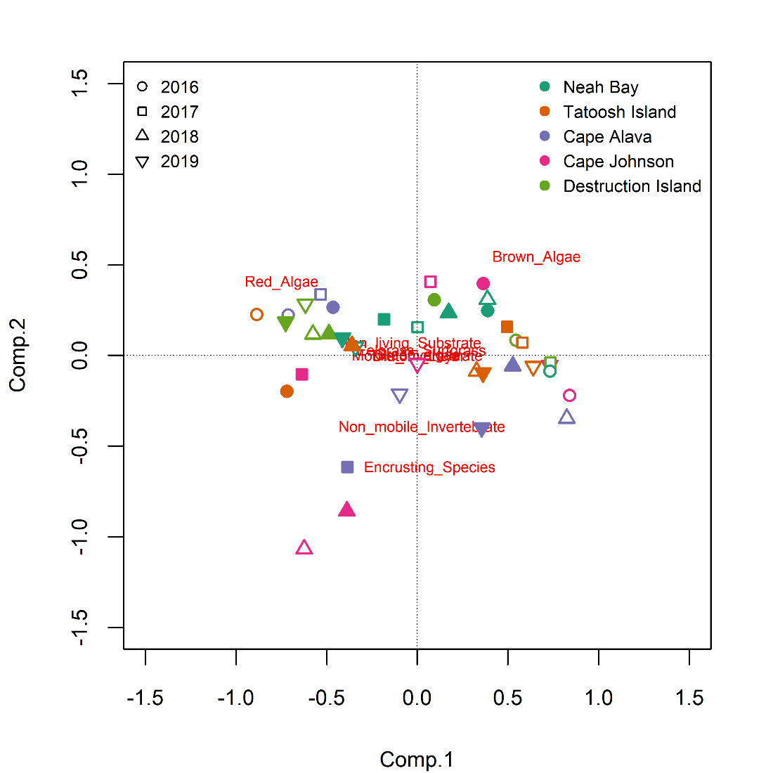

Fig. S Results of a principal components analysis ordinating biotic benthic habitat by site x year x depth. Open and closed symbols indicate 5-m and 10-m transects, respectively.

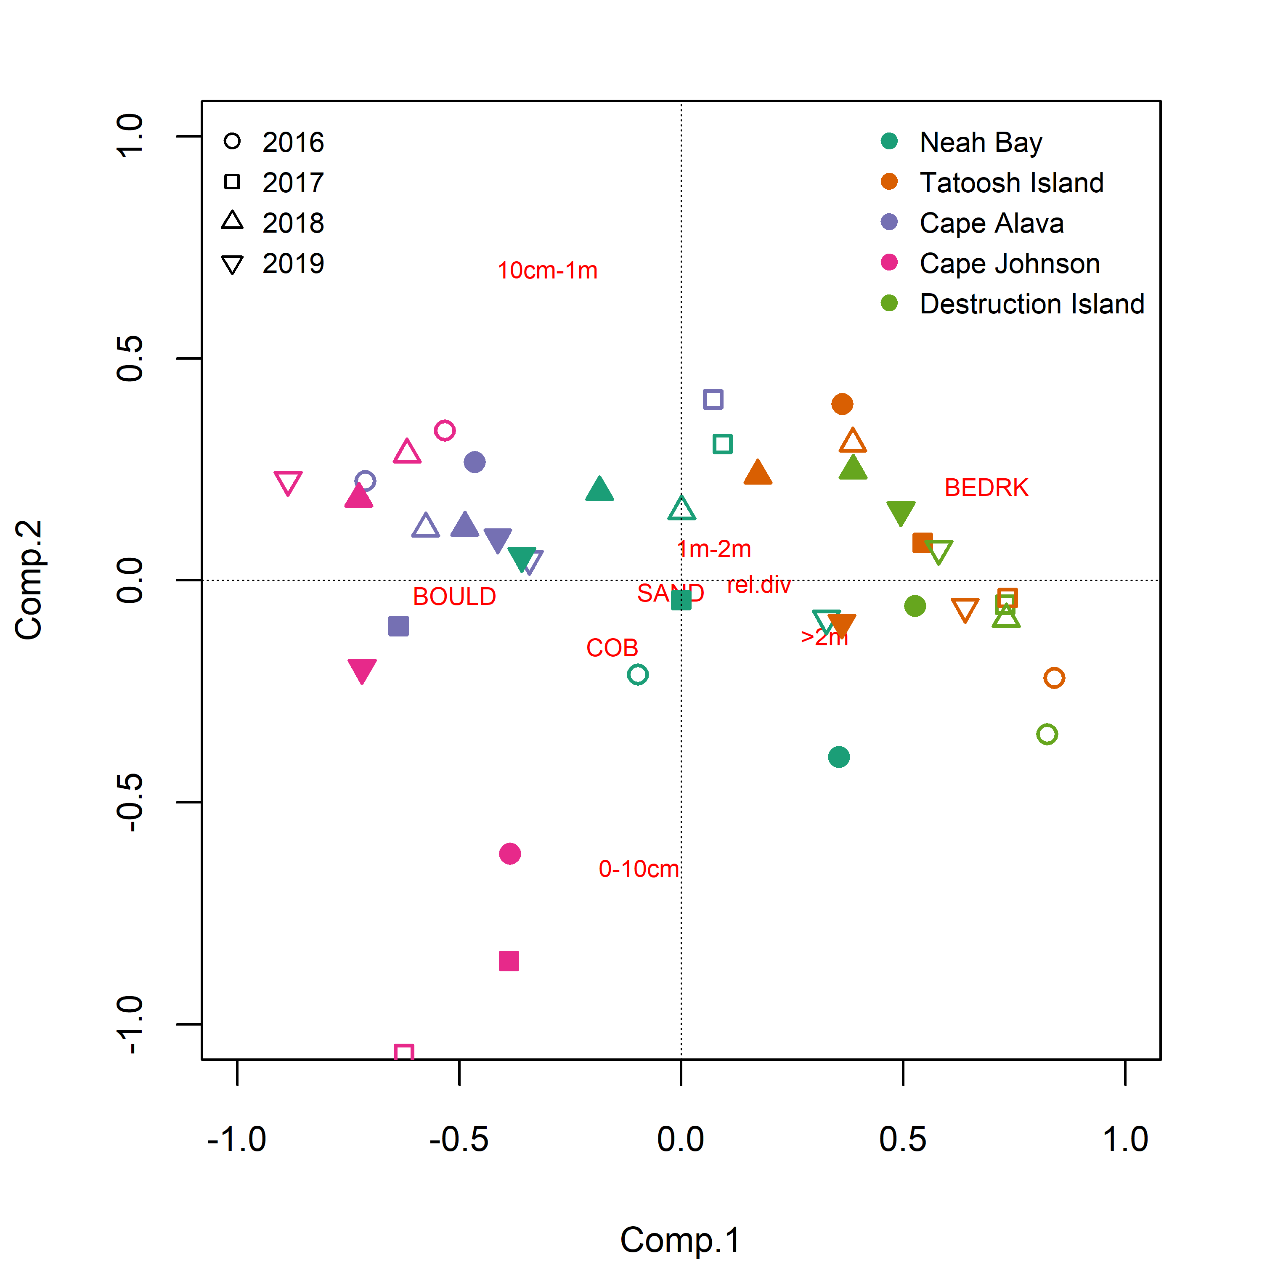

Fig. S Principal components analysis of abiotic substratum characteristics by site x year x depth. Open and closed symbols indicate 5-m and 10-m transects, respectively. BEDRK = bedrock, COB = cobble, BOULD = boulder, SAND = sand; distance ranges (e.g., 1 m – 2 m) indicate the high mean high difference across the 2-m width of the transect – a measure of slope.

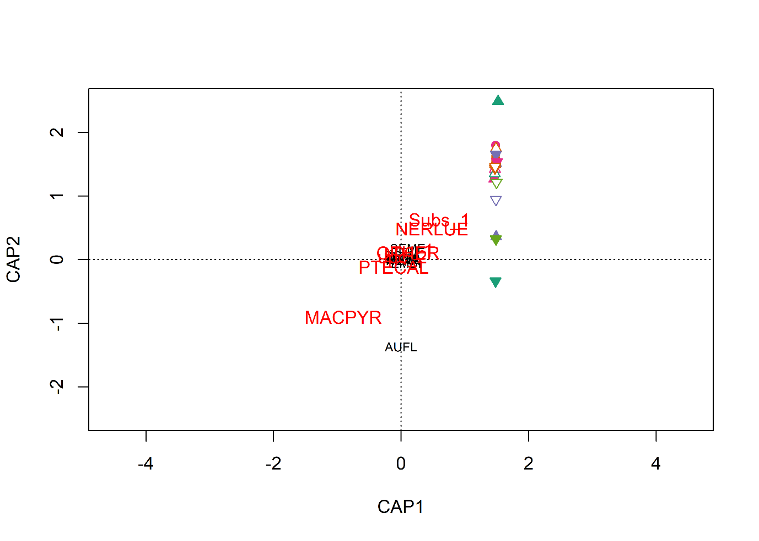

Fig. S Results of distance-based redundancy analysis with species assemblages constrained by kelp, bioitic benthic habitat, and substratum variables. The ordination was non-significant (p > 0.05).

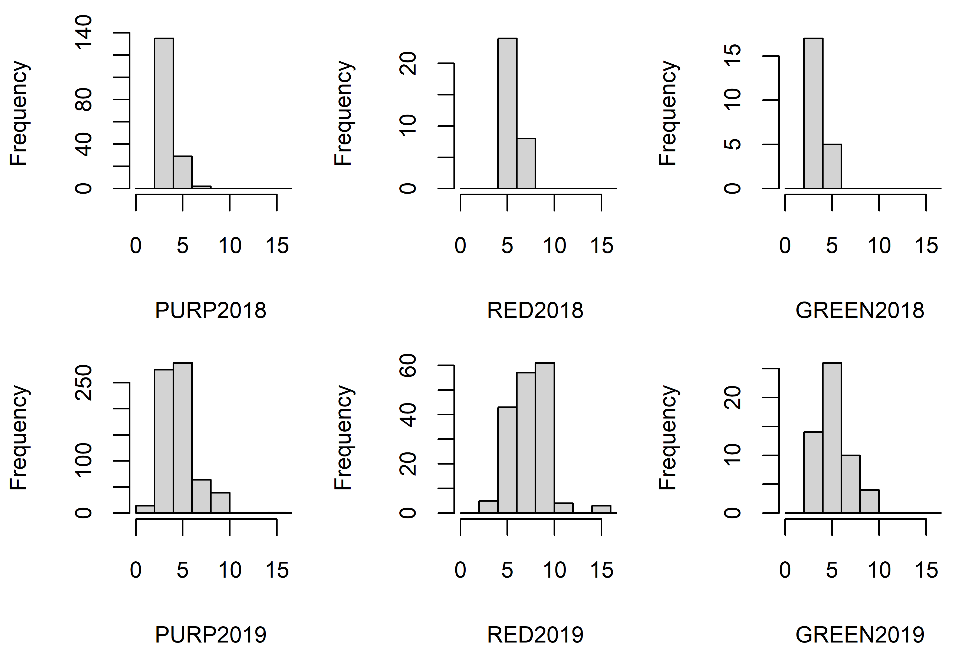

Fig. S Urchin test diameters (mm) for 2018-2019 at Tatoosh Island, WA. Note that the y-axes vary.